Mollie Makes Commission: Natural dye table linen

Issue: 128 April (on sale 25 March 21)
Deadline: 25th Jan 2021
Please send a photograph of the finished piece for approval before posting/delivering

Swatches and/or Sketches: throughout process

Fee: £130 (inclusive of materials and postage)

P.O. to follow

Please send over swatches and sketches as you’re working on the project so we can get an idea of how it’s progressing. That way, we can make sure we’re both on the same page before you finish. After you have read through the brief, let me know if you have any questions at all.

Overview:
A dyeing and sewing tutorial for a table linen set in your signature Kaliko style. This will be an easy to follow project for our Spring issue, inspiring readers to update their home for the new season in a slower and more sustainable way using natural materials and simple quilting techniques.

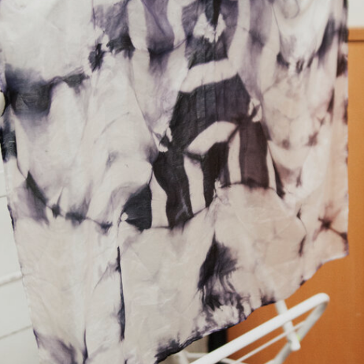
Please supply the finished 500-word tutorial in 12 steps, with 12 step photographs showing key parts of the make (see below for full requirements), a styled photograph of the finished item, and send the finished project in by midday on the deadline day for photography.

Skill level
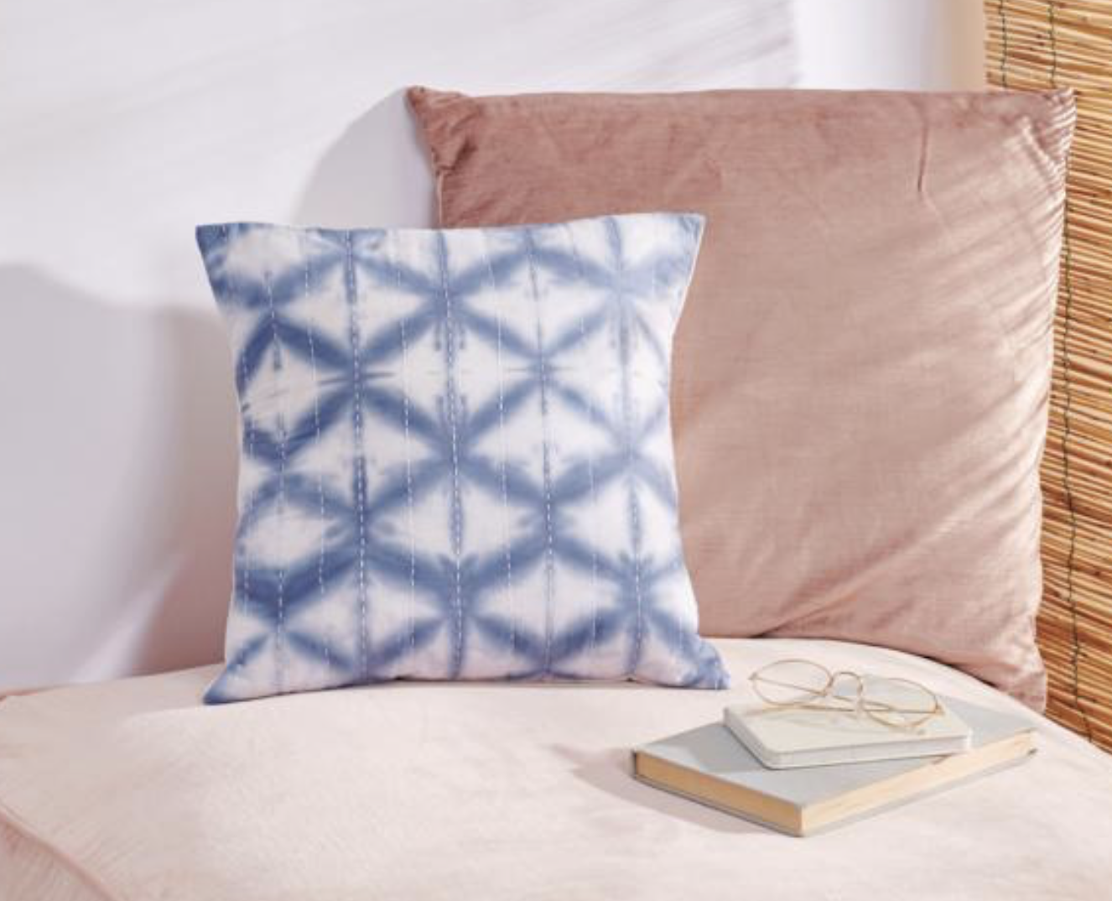
Beginner to intermediate

Inspiration

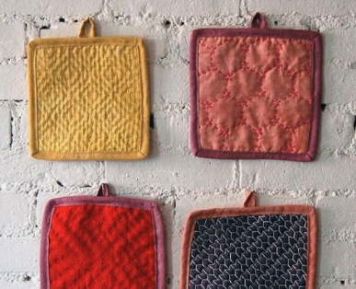
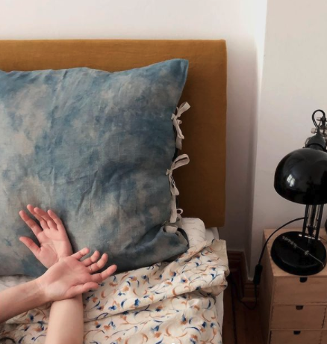
We’d like you to create a naturally dyed table linen set consisting of four rectangular fabric placemats and four co-ordinating square fabric coasters. Please use a green colour palette, a resist dye technique and include simple modern quilting details to add texture (wholecloth quilting rather than patchwork). This could be as simple as just straight parallel lines of stitching.
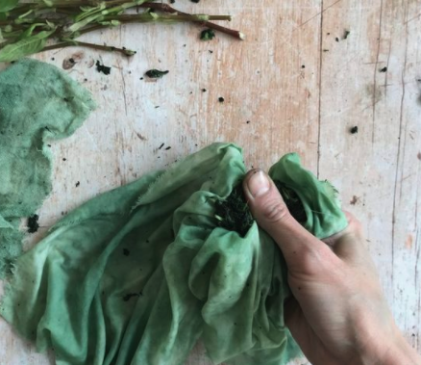

Dimensions

Placemats approx. 35 x 50cm

Coasters approx. 10 x 10cm

Please refer to the images here to inspire your project.

The tutorial should cover:

How to prepare the materials and fabric

How to resist dye with natural materials

How to add simple modern quilting details

Any finishing sewing techniques e.g hemming the edges/binding

Please approve your design and colours with us before you get going.

Please provide us with the following and send the finished item to the address below:

Yvette Streeter
Mollie Makes
3 Blaisdon
Weston-super-mare
BS22 8BL
UK

WORDS:

Your name as you’d like it to appear.

1. Materials list. Please list all branded materials or tools used, or let us know where you sourced them. Please check that materials are not about to be discontinued, and that the project can be easily made with an alternative if need be (mostly applicable to knit/crochet projects).

2. Abbreviations (if relevant)

3. A 500-word step-by-step walkthrough for the project that relates to each picture. Please mark-up which step belongs with each picture by numbering them in the same way (Step 1, Step 2, Step 3 etc).

4. 3 special tips relating to the project that we can use in the intro, or elsewhere on the page.

5. 50 words about yourself that are written in the third person: your life, hobbies, crafts, loves and a URL to your blog/Etsy shop etc.

6. 50 words about yourself that are a bit more quirky, light-hearted and fun, written in the third person, which we can use on our contributors’ page. For example: "Lara always wanted to be a ballerina, and can often be found twirling around her studio when she’s not busy designing."

7. Details of your blog/website/Etsy shop.

NOTE: Please send everything listed above within ONE Word document. Please do not send as a PDF.

IMAGES:
1. High res photographs for each step listed in your instructions, named in the same way (Step 1, Step 2, Step 3 etc.). High res is 300dpi at A4 size for this feature. If you send images not taken by you, please give us the photographer contact details so we can clear usage rights. Please keep to 12 steps. If you require more or fewer steps, let us know. Please take all shots on the same natural plain/light background for consistency. Landscape.

2. A high res image of the finished project in a styled/propped setting (for our Next month page and for our reference).

3. Templates or charts, if needed. Please provide as a JPG (or PDF) at full size.

4. A high res image of yourself.

5. 5 additional images of your work, or of you at work, to be included alongside your bio.

NOTE: Please send all of the above together, labelled and filed into folders as neatly as possible. If your images are too large to send over email, please use a Dropbox share link, WeTransfer or a similar file-sharing site to get your work to us.
DO NOT provide multiple shots for each step in your instructions (unless it requires two stages such as: Step 1a, Step 1b) – instead, choose the best shots to illustrate each step. ***

Even if you have sent in some of the items above for features in a previous issue (head shots, personal bio etc.), we DO need you to send them all in to us again – alongside your new project assets.

Please send your work to Becca Parker (rebecca.parker@immediate.co.uk) before midday on deadline day.

Please send your invoice to accounts.payable@immediate.co.uk referencing the P.O. number. It is important you also include your Contributor Invoice Number. If you don't have a system for that, just use 001 or something similar. If you're claiming VAT, please make that clear. Please make sure you fill in your bank details as we pay by bank transfer.

If you have any questions regarding the brief, let us know. For contract queries, please contact Emma Brunt (emma.brunt@immediate.co.uk). For invoice queries, please contact accounts (address above).

PLEASE DO NOT share photos or information about your commission on your social media channels/blog until the issue goes on sale. We like to keep our content exclusive and surprising to our readers.

Many thanks!

Becca

